Decision Scenario
Part 1: Description of Decision
At 21, while working as a swim coach, I decided to open a swim school with a colleague twelve years older than me. She had worked in the industry for 17 years, held coaching accreditations, and had previously run her own businesses, including a childcare education centre. We agreed on a 50/50 partnership with a total investment of $80,000 for rental and set-up. My share was $40,000 ($10,000 from my savings and $30,000 borrowed from her). Owning a business at that age was a large part of the appeal. I estimated our chance of success at about 60%. We both had steady clients and referrals, and my main worry was whether clients would follow us to a new pool.
Unfortunately, the school later had to close after 8 months because the premises did not meet the area’s business categorisation. Initially, I was 90% confident the premises were legal to use, because I assumed someone with her experience would know the ins and outs of administrative issues. I did not contact the land or business zoning authorities myself. When we mentioned the plan to friends, one knew of someone who tried a similar location and failed. We attributed this to that particular location and moved forward with our decision, since the area was different.
Part 2: What would I do differently?
I would re-run the decision-making process using Expected Utility Theory (von Neumann and Morgenstern, 1944) in four steps. Step 1: Options. I would set the decision out as two choices in sequence (Figure 1). First: to start the venture or not. Second, if starting: verify the administrative and zoning requirements before committing the money, or proceed without verifying, as I did. Step 2: Utilities. I would rate how good or bad each outcome would feel on a scale from -50 to +50. A business that runs but whose clients do not follow scores +10. Being forced to close, losing $10,000 and owing $30,000, scores -40. Walking away after finding the site non-compliant scores -20, as does never investing, which reflects regret at a missed opportunity.
Step 3: Probabilities. My 90% confidence in the premises rested on my partner’s experience, but that experience says little about the zoning of one specific unit. Using Bayesian inference, I would treat the friend’s story as evidence rather than dismissing it (Figure 2). If the story is 0.30 likely when the site is legal and 0.80 likely when it is not, my confidence falls to 0.77 (0.27/0.35). The risk of non-compliance therefore rises from 0.10 to 0.23. Combining this with my 60% chance of success gives three outcome possibilities: legal and successful, 0.77 x 0.6 = 0.462; legal but struggling 0.77 x 0.4 = 0.308; and not legal = 0.23.
Step 4: Finding the Net EU. For each option, I multiplied each outcome’s probability by its utility and added the results (Figure 3). Working backwards, Verifying (+21.6) beats not verifying (+17.0), so starting the venture is worth +21.6, far above not starting (-20). The rational path is to start the venture but verify first. It does not change the success; it turns the worst outcome of a -40 loss into a -20 disappointment.
Part 3: Comparison and reflection
Comparing the two approaches, the critical thinking process differs in three ways. It adds a second decision: whether to verify, which I never considered. It treats the friend’s story as evidence, lowering my confidence that the site was legal from 90% to 77%. And it makes trade-offs explicit rather than resting on trust. Dismissing the story reflects confirmation bias, favouring evidence that supports a prior belief (Halpern & Dunn, 2023; Nickerson, 1998), while treating my partner’s general experience as proof of legality reflects an appeal to authority (Halpern & Dunn, 2023).
However, the systematic approach does not guarantee a better outcome. Decision quality differs from outcome quality (Baron & Hershey, 1988): starting the venture scored far above not starting, and the business could still have failed for other reasons. Knowing that may make the risk look more obvious than it was (Fischhoff, 1975), but the probabilities and utilities remain subjective. The model also assumes checking was costless, ignoring a week’s delay and the awkwardness of questioning a more experienced partner who needed financial stability.
Even so, verifying first (+21.6) beats proceeding unchecked (+17.0), so I conclude that the module approach would probably have produced a better process: a simple check could have prevented a $10,000 loss and $30,000 debt. In future, I would personally verify legal requirements before investing.

References
Baron, J., & Hershey, J. C. (1988). Outcome bias in decision evaluation. Journal of Personality and Social Psychology, 54(4), 569. https://doi.org/10.1037//0022-3514.54.4.569
Fischhoff, B. (1975). Hindsight is not equal to foresight: The effect of outcome knowledge on judgment under uncertainty. Journal of Experimental Psychology: Human Perception and Performance, 1(3), 288–299. https://doi.org/10.1037/0096-1523.1.3.288
Halpern, D. F., & Dunn, D. S. (2023). Thought and knowledge: An introduction to critical thinking (6th ed.). Routledge.
Nickerson, R. S. (1998). Confirmation Bias: A Ubiquitous Phenomenon in Many Guises. Review of General Psychology, 2(2), 175–220. https://doi.org/10.1037/1089-2680.2.2.175
von Neumann, J., & Morgenstern, O. (1944). Theory of games and economic behavior. Princeton University Press.

Appendices
Figure 1.
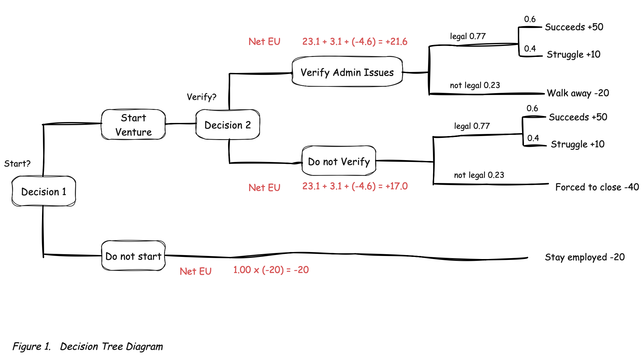
Figure 2.
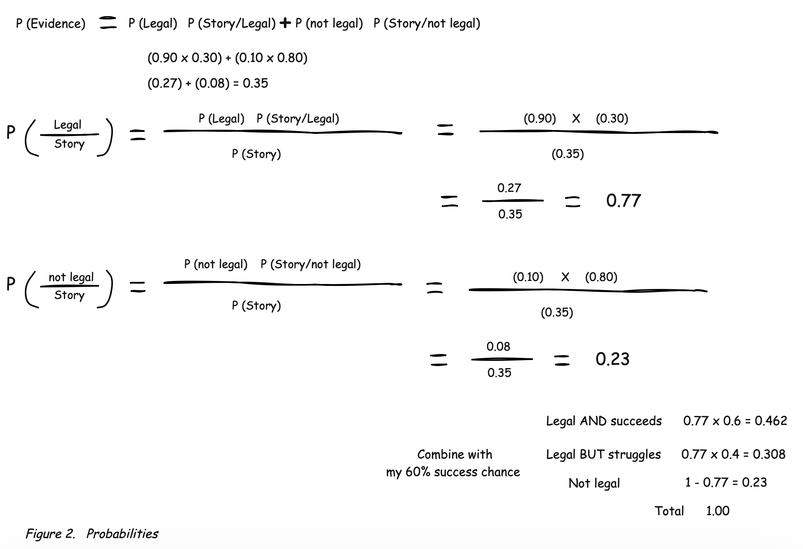
Figure 3. 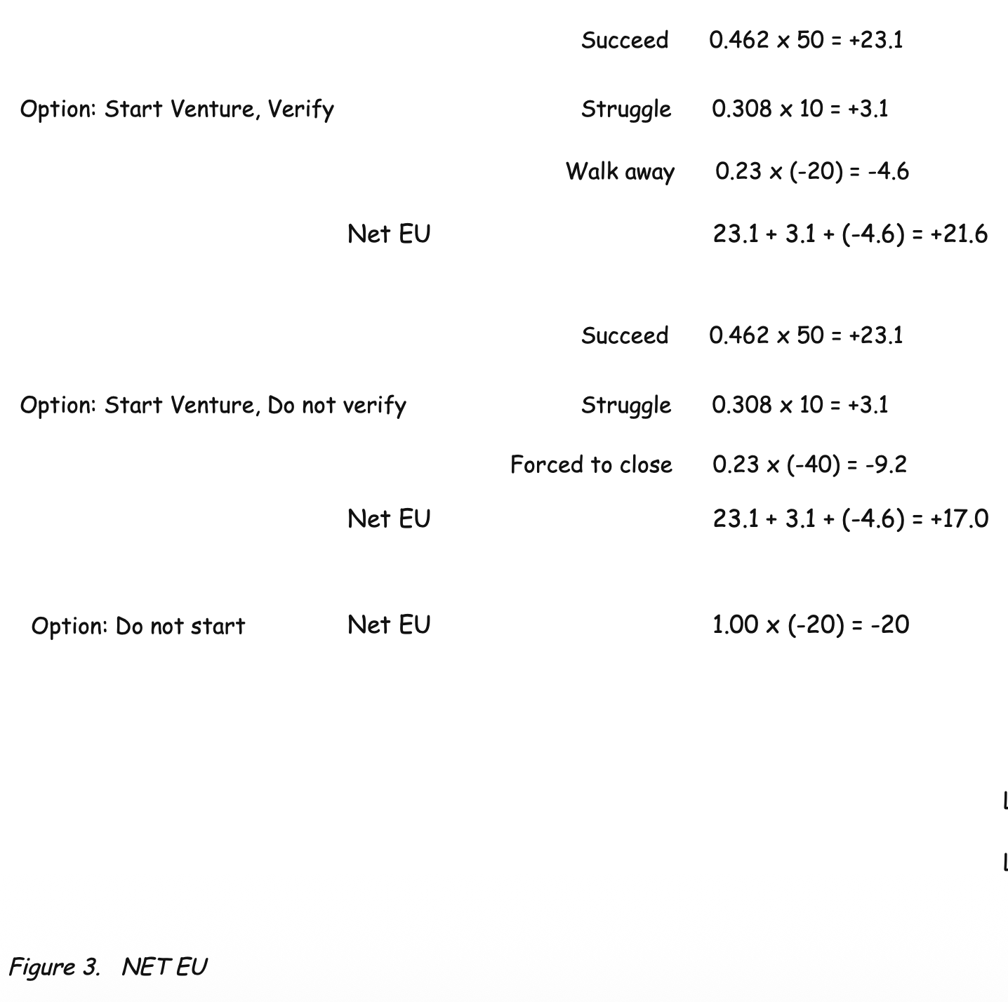

Problem Scenario
Part 1: Description of problem
Earlier this year, when our landlord renewed the lease for our main food and beverage stall, they paired it with a second stall in a quieter residential area. It is common practice to bundle a good location with a poor one. Due to the setup cost of the second location and the lower foot traffic, the second stall lost money every month. Even with the main stall’s steady customers, built over 15 years, our profits could not cover the losses.
Mid-year, the landlord announced a major renovation at the main stall and asked all tenants to sign a new lease. This meant another rent increase, a share of the $80,000 renovation fee, moving and storage costs, and two months of foreign workers’ salaries, on top of the second stall’s losses. We sat down to brainstorm three options: find a new location, move to a central kitchen, or sell the business. None of them felt right.
A businessman friend suggested paying a large sum to break the second stall’s contract or closing the company, while my father-in-law, who had passed the stalls to us, suggested letting it run at a loss until the lease ended in two years. We then advertised the second stall for takeover at zero fees. There were many enquiries, but once we passed them to the landlord, we never heard back. We were stuck. Unexpectedly, a fellow stall owner with franchises called, wanting to take over the main stall under the new lease. We asked him to take the second stall as well, and he agreed.
Part 2: What would I do differently?
I would re-run the problem-solving process using Newell and Simon’s problem space, in four steps (Halpern & Dunn, 2023).
Step 1: Define the goal more clearly. The problem was ill-defined (Halpern & Dunn, 2023), so I would restate the goals in several ways: stop the losses, keep the profitable stall, or exit both stalls cleanly. Choosing “exit both stalls with minimum loss” as the main goal narrows the options.
Step 2: Map the problem space. The initial state was two bundled stalls facing rising costs, and the goal was a clean exit. The constraints were the landlord’s approval of any takeover, the bundling practice and the two-year lease. The operators were the options we generated, from relocating to paying to break the contract.
Step 3: Breaking it down to subgoals. Using means-ends analysis (Halpern & Dunn, 2023), I would separate exiting the second stall from deciding the main stall’s future. We treated them as one problem, which is why no single option fitted. Separated, the link becomes clear: the main stall, which the renovation costs gave us reasons to leave, was the asset a taker would want.
Step 4: Break the impasse. Passing every enquiry to the landlord and waiting was the same failed move repeated, a sign of mental set (Bilalić et al., 2008). Representational restructuring (Öllinger et al., 2014) means asking why it failed and working backwards from the goal (Halpern & Dunn, 2023). A takeover happens only if the landlord approves, so the question becomes which tenant the landlord wants. An existing stall owner or franchise operator, offered both stalls as one package, fits far better than an unknown individual. In effect, we would use the landlord’s bundling in reverse, turning the constraint that caused the problem into the solution.

Part 3: Comparison and reflection
Learning the critical thinking skills in this module has shown me three ways in which my approach to thinking has changed. First, I now break the problem into subgoals rather than looking for a single solution to fix everything. Second, I consider who or what is limiting the outcome, recognising the landlord as the constraint rather than a lack of interest. Third, I try to generate potential solutions rather than deliberately instead of waiting for chance. Looking back, our repeated referrals reflect mental set, and seeing the main stall only as a source of income rather than a bargaining asset resembles functional fixedness (Halpern & Dunn, 2023; McCaffrey, 2012).
However, the outcome resulted from an unexpected call, not from our method. A more deliberate search may not have found a suitable operator any sooner, as the landlord’s decisions were outside our control. The problem-space model also simplifies a negotiation in which our goals and constraints changed throughout the year, and knowing the final solution worked may make the outcome seem more obvious in hindsight than it was (Fischhoff, 1975).
Nevertheless, applying the module’s approach may have reduced the time we spent stuck and helped us rely less on chance. In future, I would break complex problems into smaller subgoals and identify early which aspects of the outcome are within my control.

References
Bilalić, M., McLeod, P., & Gobet, F. (2008). Why good thoughts block better ones: The mechanism of the pernicious Einstellung (set) effect. Cognition, 108(3), 652–661. https://doi.org/10.1016/j.cognition.2008.05.005
Fischhoff, B. (1975). Hindsight is not equal to foresight: The effect of outcome knowledge on judgment under uncertainty. Journal of Experimental Psychology: Human Perception and Performance, 1(3), 288–299. https://doi.org/10.1037/0096-1523.1.3.288
Halpern, D. F., & Dunn, D. S. (2023). Thought and knowledge: An introduction to critical thinking (6th ed.). Routledge.
McCaffrey, T. (2012). Innovation Relies on the Obscure: A Key to Overcoming the Classic Problem of Functional Fixedness. Psychological Science, 23(3), 215–218. https://doi.org/10.1177/0956797611429580
Öllinger, M., Jones, G., & Knoblich, G. (2014). The dynamics of search, impasse, and representational change provide a coherent explanation of difficulty in the nine-dot problem. Psychological Research, 78(2), 266–275. https://doi.org/10.1007/s00426-013-0494-8

